Laboratory WORK REPORT №2

«Operational amplifiers circuits design»

**Principles of Circuits**

Student: CAO Xinyang 20321308

Program of Computer Science and Technology

group CS

Name Surname

# Work purpose: to study parameters of Operational Amplifier and basis of Operational amplifiers circuits design

Goals:

1) Design amplifier model on the basis of operational amplifier «Inverting amplifier»

2) Simulate amplifier scheme and analyze dependencies of output voltage from load and resistor values variation

3) Analyze time domain and frequency domain of amplifier

4) Simulate underpower state/power supply check

# Starting data

* **Required gain of amplifier $K_{NI}=$** -2.000
* **Required tolerance $:{ΔK}_{NI_{OPAMP}}=$**3%
* **Operational Amplifier : Inverting amplifier**
* **Voltage source power supply** VPP+ $=9$ (V) / VPP $-=9$ (V)
* **Frequency for time domain simulation**

$f_{test_1}=100$ (Hz)

$f_{test_{2}}=$ 2000 (Hz)

$f_{test_{3}}=$ 200000 (Hz)

* **Test signal voltage magnitude**

$V_{test_{AC}}=V_{test}=0.5$ (V)

* **Resistor parameters**

$R_{1}=11000$ (Ω)

$R_{fb}=6000$ (Ω)

$R_{3}=19500$ (Ω)

$R_{4}=20001$ (Ω)

$R_{Load}=$ 1000000 (Ω)

* **Amplifier scheme:** Inverting amplifier

# Simulation

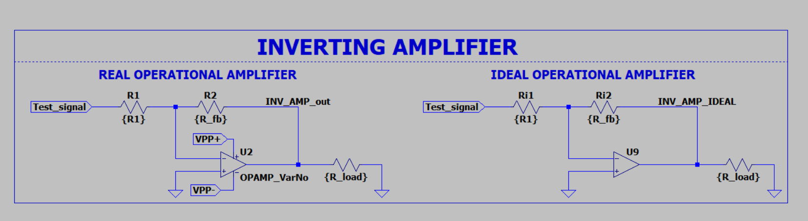

Figure 3.1 – Inverting amplifier scheme

## Gain evaluation:

Gain evaluation with new resistors

$$K_{NI}=-\frac{R_{fb}}{R_{1}}=-0.5455$$

$$K_{{NI}_{max}}=-\frac{R_{fbmax}}{R_{1min}}=-\frac{R_{fb}(1+M)}{R_{1min}(1-M)}=-0.5565$$

$$K_{{NI}_{min}}=-\frac{R_{fbmin}}{R_{1max}}=-\frac{R_{fb}(1-M)}{R_{1min}(1+M)}=-0.5347$$

Define maximum deviation from $K_{NI}$ defined by resistance tolerance

$$E_{NI_{R+}}=\left|\frac{K_{{NI}_{max}}-K_{NI}}{K_{NI}}\right|=0.0202$$

$$E_{NI_{R-}}=\left|\frac{K_{{NI}_{min}}-K_{NI}}{K_{NI}}\right|=0.0198$$

${ΔK}_{NI_{OPAMP}}=$ max of $E_{NI_{R+}} and E_{NI_{R-}}$ = $0.0202$

Table 1. Parameters of the amplifier

|  |  |  |  |
| --- | --- | --- | --- |
| Обозначение | Simulation | | |
|  | Nominal | With tolerance variation | |
| R1, kΩ | 11 | 1% | |
| R2, kΩ | 6 | 1% | |
| RLoad, kΩ | 1 000 k (ideal) | 100, 1000, 10000, 100000 | |
| $$K_{NI}$$ | -0.5455 | 0.0202 | |
| $$K_{{NI}_{max}}$$ | -0.5565 | 0.0202 | |
| $$K_{{NI}_{min}}$$ | -0.5347 | 0.0198 | |
| $${ΔK}_{NI_{OPAMP}}$$ | 0.0202 | | 0 |

## Time domain simulation results

### $f_{test_1}=100$ (Hz)

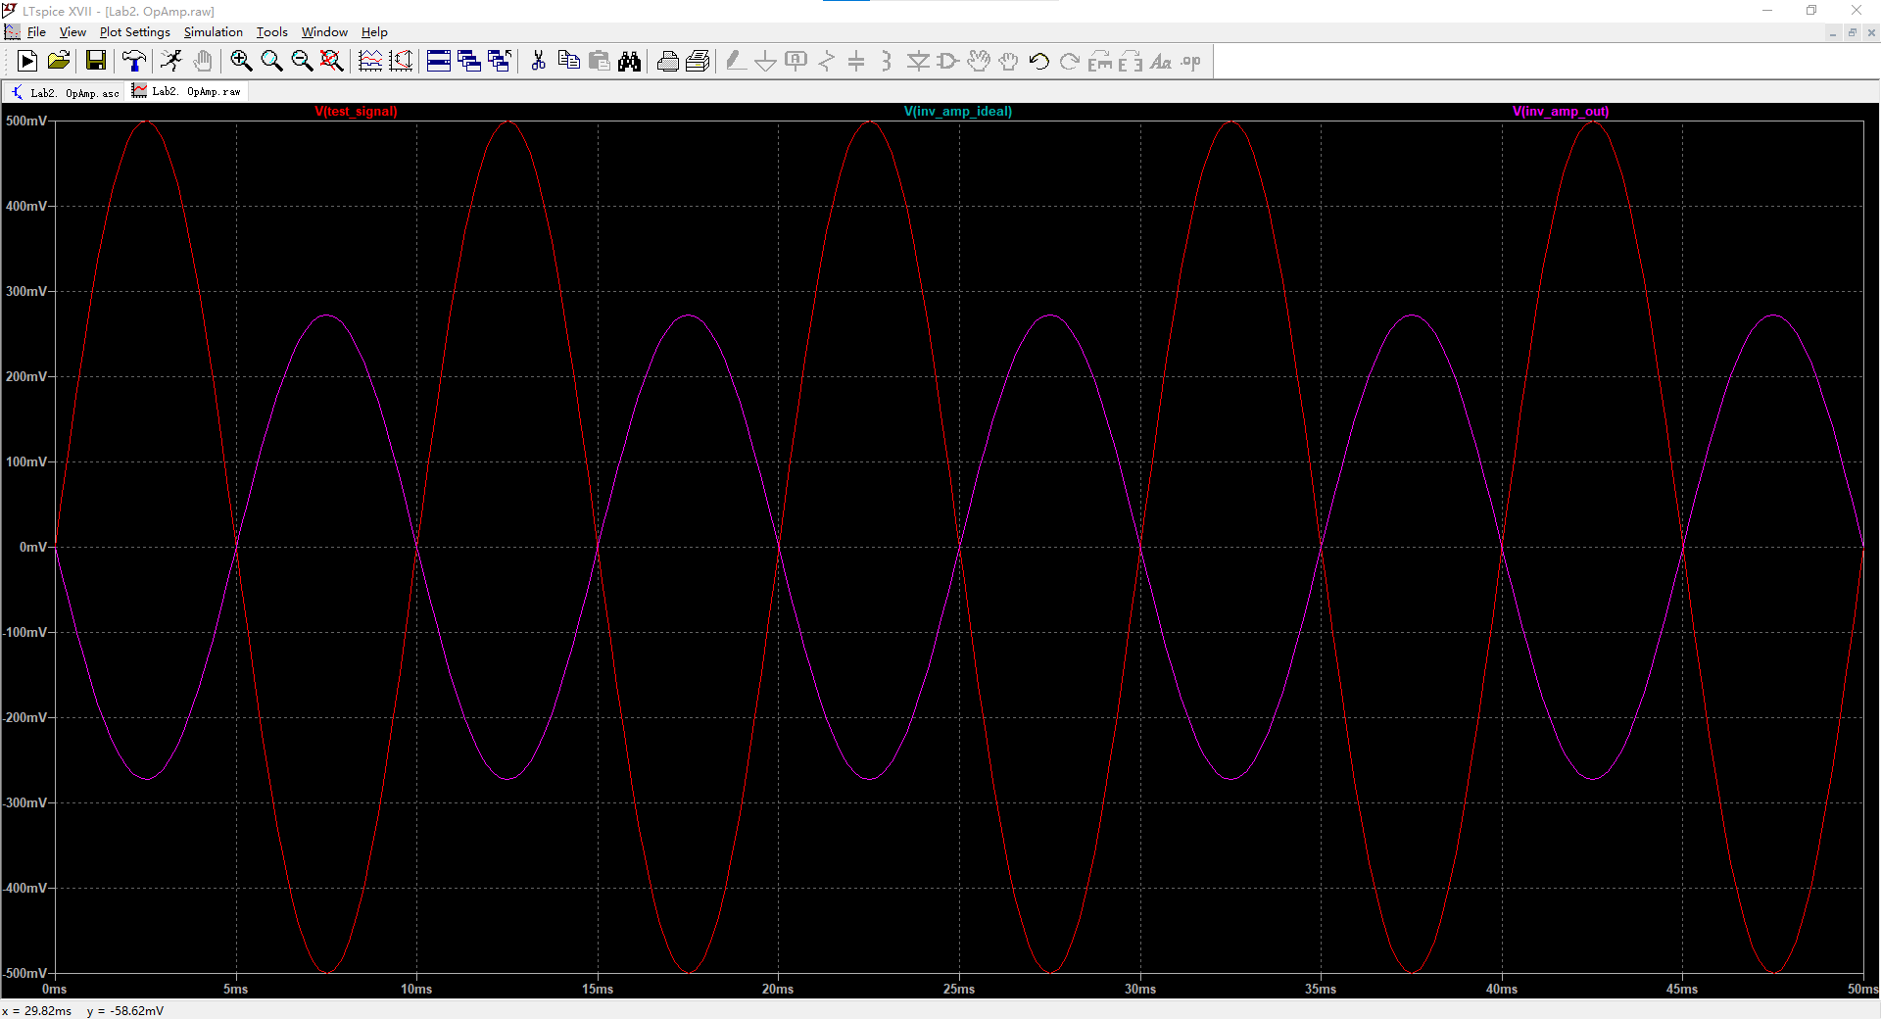

Figure 3.2 – Input and output voltages of ideal and real operational amplifiers

$f_{test_1}=100$, $K_{NI}=4$, $R_{1}$ variation 1%, $R_{fb}$ variation 1%

### $f_{test_2}=2000$ (Hz)

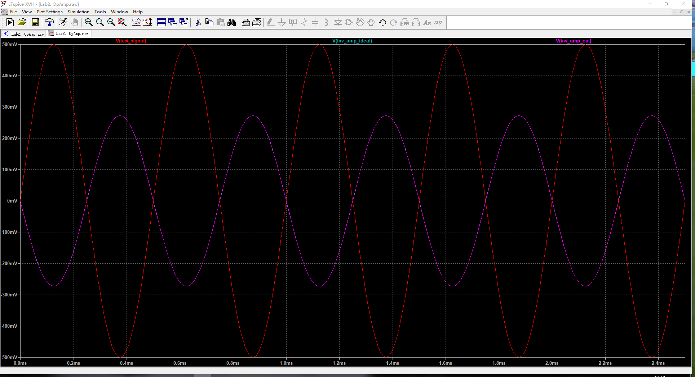

Figure 3.3 – Input and output voltages of ideal and real operational amplifiers

$f_{test_{2}}=2000$, $K_{NI}=4$, $R_{1}$ variation 1%, $R_{fb}$ variation 1%

### $f_{test_3}=200000$ (Hz)

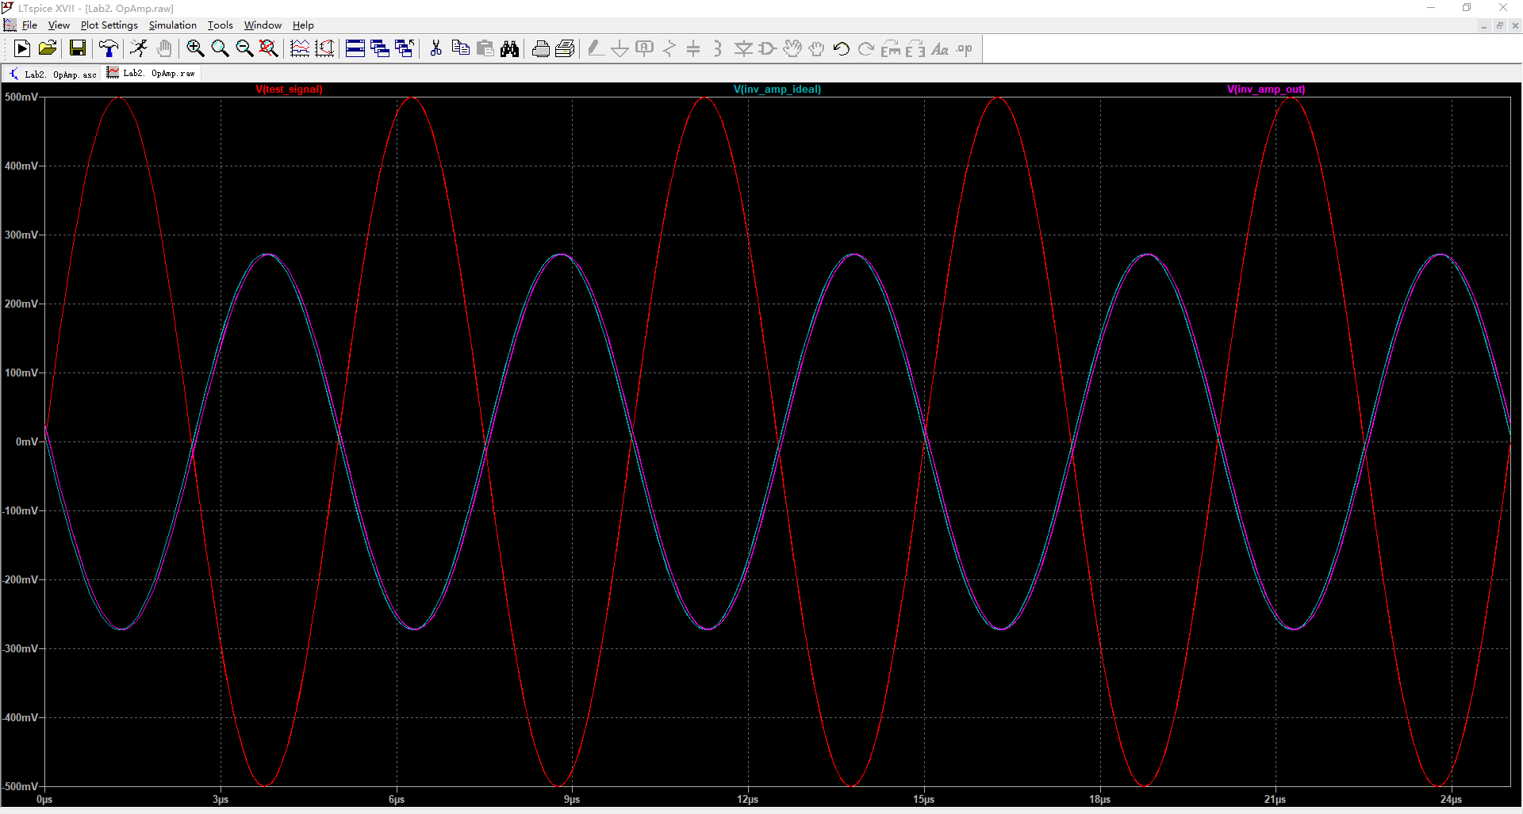

Figure 3.4 – Input and output voltages of ideal and real operational amplifiers

$f_{test_3}=200000$, $K_{NI}=4$, $R_{1}$ variation 1%, $R_{fb}$ variation 1%

## Frequency domain simulation results

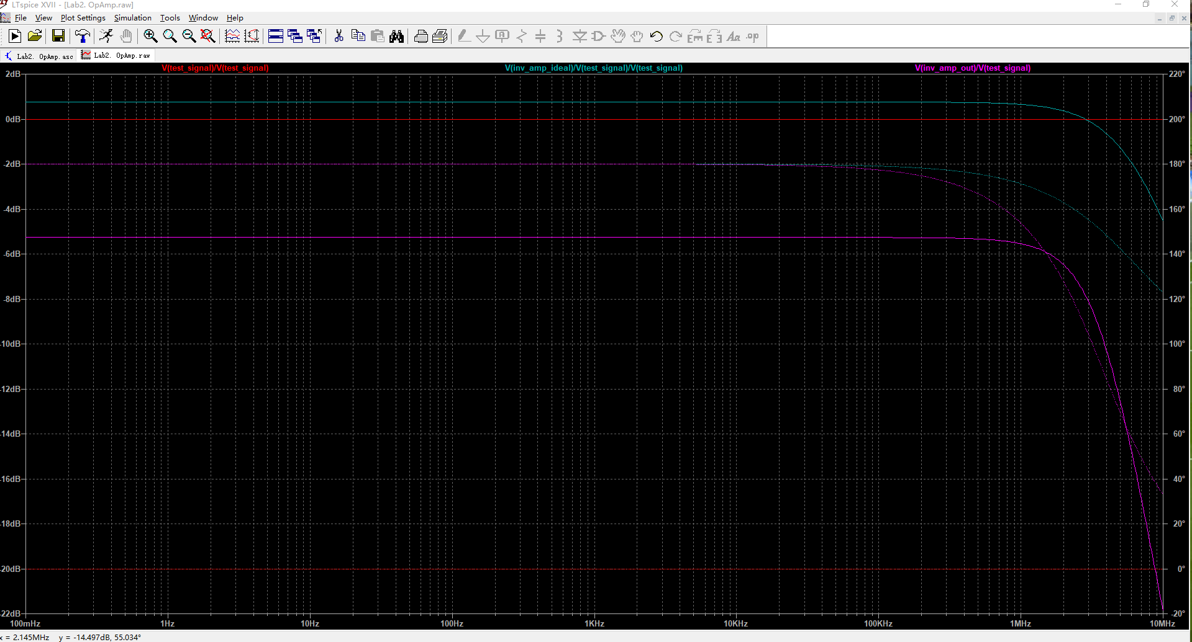

Figure 3.5 – Input and output voltages of ideal and real operational amplifiers

$K_{NI}=-0.5455$, $R_{1}$ variation 1%, $R_{fb}$ variation 1%

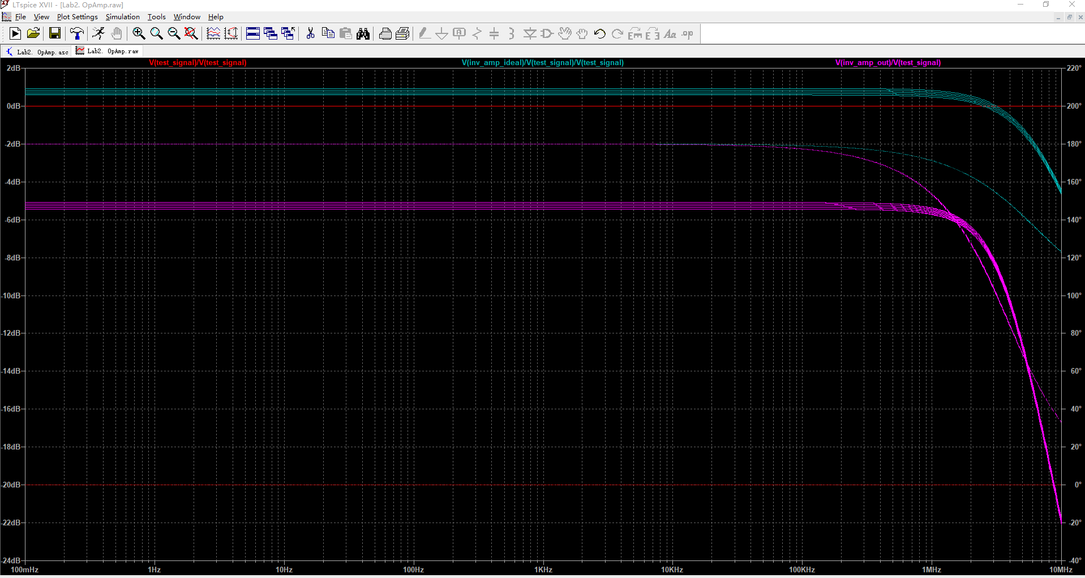

Figure 3.6 – Input and output voltages of ideal and real operational amplifiers

$K_{NI}=-0.5455$, $R_{1}$ variation 1%, $R_{fb}$ variation 1% and $R_{Load}$ variation

### Simulation results

|  |  |  |  |  |  |  |
| --- | --- | --- | --- | --- | --- | --- |
|  | **Ideal** | **VarNo** | **Ideal** | **VarNo** | **Ideal** | **VarNo** |
| **frequency, kHz** | 100 | | **2000** | | **200000** | |
| **Vtest, V** | 0.5 | 0.499 | 0.5 | 0.501 | 0.5 | 0.5 |
| **Vout, V** | -0.27 | 0.269 | -0.27 | 0.271 | -0.27 | 0.27 |
| KNI_exp | -0.55 | -0.54 | -0.55 | -0.54 | -0.55 | -0.55 |
| ΔKNI | 0.0202 | 0.0182 | 0.0202 | 0.0182 | 0.0202 | 0.0202 |
| $$E_{NI_{max}}$$ | 0.0202 | 0.0182 | 0.0202 | 0.0182 | 0.0202 | 0.0202 |
| KOL | -27.23 | -15.13 | -27.23 | -15.13 | -27.23 | -27.72 |

# Conclusions

Conclusions should contain:

1. Is it possible to realize amplifier with defined gain and gain tolerance?

Yes.

1. In which range can be load resintace $R_{Load}$ variated?

10k ~ 100k

1. How was operational amplifier power supply modified?

By using vpp.